**A**

**PROJECT REPORT**

**ON**

Cultivator’s Corner

An Online Food Merchandise Store

Submitted in partial fulfillment for the award of

**Post Graduate Diploma in Advance Computing**

**(PG-DAC) from**

**INSTITUTE OF EMERGING TECHNOLOGIES**

**Authorized Training Centre**



UNDER THE GUIDANCE OF

**Ms. Kishori Khadilkar.**

**BY**

|  |  |  |
| --- | --- | --- |
| 240845920001 |  | Abhijit Deshmukh. |
| 240845920023 |  | Divyansh Singh. |
| 240845920030 |  | Harshit kumar. |
| 240845920034 |  | Manoj Jadhav . |
| 240845920094 |  | Vaishnavi Hingmire. |
|  |  |

# ACKNOWLEDGEMENT

The project “Cultivator’s Corner” was a great learning experience for us and we are submitting this work to Advanced Computing Training School (C-DAC ACTS, Pune).

We are very glad to mention the name of Ms. Kishori Khadilkar for her valuable guidance to work on this project.

We are highly grateful to Ms. Risha P. R., Manager of ACTS Training Centre, CDAC, for her guidance and support whenever necessary during the course of our journey to acquire PG- Diploma in Advanced Computing (PG-DAC) through CDAC ACTS, Pune.

Our heartfelt thanks go to Ms. Shilpi Shalini (Course Coordinator, PG_DAC) who gave us all the required support and kind coordination to provide all the necessities to complete the project and throughout the course up to the last day of the course.

|  |  |
| --- | --- |
| **240845920001** | **Abhijit Deshmukh.** |
| **240845920023** | **Divyansh Singh.** |
| **240845920030** | **Harshit Kumar.** |
| **240845920034** | **Manoj Jadhav.** |
| **240845920094** | **Vaishnavi Hingmire.** |

We would like to express our sincere gratitude towards Mrs. Madhura Anturkar, our faculty for J2SE and J2EE, who was always there for us. Her guidance and support throughout the course helped us to overcome various obstacles and intricacies during the course of our project work. Without her tremendous support, guidance, and efforts, this project would not have been possible.

Sign of student

**Name of Students**

**PRN No.**

ABSTRACT

The Business to Consumer Model has come a long way ever since it time of inception. While it has expanded into multiple types of goods, there is still a section of market that remains untapped: Fresh goods. As the current generation of consumers is becoming more and more health conscious, and with current trends of organic food, Fresh foods can become the next big thing in e-commerce.

This project deals with developing an e-commerce website for online fresh foods product sale. It provides list of farmers that offer fresh fruits and vegetables, and products page for each farmer’s offerings. It also provides a cart for ease of remembering the choices selected by user. The user can also view their order history to go back to the farmer from whom they purchased the last batch of products.

Two main technologies were used in this project: Java and React. Java was used for backend. React is used for client side rendering of the page, which offloads the load of rendering views to the client, and provides a fluid single page experience. MySQL has been used as database to store list of users, farmers and their products.

This project has been designed and implemented in multilevel architecture so as to have minimum coupling and maximum cohesion.

# 1 .INTRODUCTION

Fresh produce industries across the world are facing a roller-coaster ride of new developments and trends. Although there might be a few tight turns and steep slopes, the latest trends paint an inspirational picture of what lies ahead in the next five to 10 years.

In the fresh produce sector, technology and retail innovations abound. From futuristic hi-tech grocery stores, the rise of e-commerce opportunities, culinary innovation centers and revolutionary robotics technology to vertical farming and plant-based food innovations like cauliflower pizza and vegetable steaks.

Online Shopping of Fresh Food opens up a new world of options. Users won’t have to go from store to store to hunt for fresh food. They won’t have to worry about wondering whether their food is organic or inorganic. They will be able to refill their fridges in just one click, all while sitting at home.

Our system offers one stop solution to all fresh food needs. Users can log into their accounts and then they will be taken to produces offered by the farmer.

Customer can pick what foods they want to order and add to the cart. Once they are done selecting what they require, after reviewing cart summary they can simply click on check out button to pay bill and they will get an order details pdf on their registered email for the same. Their cart will be delivered to their houses.

This can be done from any place, at any time all from the internet, thus making it easy to get your daily need of fresh foods.

* 1. **PROBLEM DEFINITION** **AND SCOPE**
  2. **PROBLEM DEFINITION**

The Cultivator’s Corner, as the name Suggested is about farmers and their showcased merchandise. It is about connecting farmers directly to the customers, thereby cutting the middle man. This ensure that customers get fresh foods at a very cheap price. This also ensure that all the farmers get a fair chance at gaining customers so that they don’t have to rely on any middle man.

# SCOPE

“Cultivator’s Corner” aims to deliver a web-based application that hosts a wide collection of the food-items that users can browse through. Users can place orders and make payment. They can update their profile, add delivery address .They can view their order history as well.

Admins can manage various product details like stock, price, adding new products, and categories etc. Only admin can add farmers. Admins can even delete users and/or farmers, if the need arises.

This project does not support the actual logistics and delivery of food items and actual payment logic. We are assuming that the organization that implements it will be using third-party payment API which can easily be integrated in our application if needed. Cultivator’s Corner is only an interface for both customers (for browsing and shopping for food items) and admins (for managing products, farmers, users listing).

##### 2.2 GOALS & OBJECTIVES

**GOALS:**

1. Promote Sustainable Agriculture – Encourage eco-friendly and sustainable farming techniques.
2. Empower Local Farmers – Provide resources, education, and support to farmers.
3. Enhance Food Security – Improve local food production and accessibility.
4. Encourage Community Participation – Foster a sense of community through farming and gardening initiatives.
5. Improve Agricultural Innovation – Integrate modern technology with traditional farming methods.

**OBJECTIVES:**

1. Provide Training & Workshops – Conduct educational sessions on organic farming, soil health, and crop management.
2. Support Small-Scale Farmers – Offer financial aid, tools, or market access to local cultivators.
3. Develop Community Gardens – Establish shared spaces for collective farming and food production.
4. Implement Eco-Friendly Practices – Promote composting, rainwater harvesting, and reduced pesticide use.
5. Increase Awareness – Educate people on the benefits of home gardening and self-sufficient food production.
6. Facilitate Market Linkages – Help farmers connect with buyers, restaurants, and local markets.
7. Research & Innovation – Encourage experimentation with new crops, techniques, and sustainable farming solutions.

**2.3 Major Constraints & Outcomes**

**Major Constraints:**

1. Limited Funding & Resources – Difficulty in securing financial support, equipment, and seeds for cultivation.
2. Land Availability & Space Constraints – Limited access to fertile land or urban space for farming.
3. Climate & Weather Conditions – Unpredictable weather patterns affecting crop yield and sustainability.
4. Lack of Agricultural Knowledge – Farmers and community members may require extensive training.
5. Market Accessibility – Challenges in selling produce due to competition, pricing, or lack of distribution channels.
6. Government Regulations & Policies – Legal restrictions, permits, and agricultural policies impacting operations.
7. Community Participation – Low engagement or lack of interest from local residents.
8. Infrastructure & Technology Limitations – Limited access to modern farming tools, irrigation systems, and digital platforms.

**Expected Outcomes:**

1. Increased Sustainable Farming Practices – More farmers adopting eco-friendly and organic farming methods.
2. Enhanced Food Security – Improved access to fresh, locally-grown food within the community.
3. Skill Development & Education – Farmers and participants gain knowledge in modern and traditional cultivation techniques.
4. Economic Growth for Farmers – Increased income and market opportunities for small-scale cultivators.
5. Community Empowerment – Stronger community bonds through shared gardening and cultivation efforts.
6. Environmental Benefits – Reduction in chemical usage, improved soil health, and better water management.
7. Innovative Agricultural Solutions – Development of new techniques, hybrid crops, and efficient farming models.
8. Market Expansion – Establishment of reliable sales channels, partnerships, and farm-to-table initiatives.
9. **Software Requirement Specification**

# PROPOSED SYSTEM

The proposed system for Cultivators Corner is a community-driven agricultural platform designed to promote sustainable farming, empower local farmers, and enhance food security through modern technology and traditional cultivation methods. This system will include an online portal and mobile application where farmers can access educational resources, participate in virtual training, and connect with agricultural experts. Additionally, a farmers' marketplace will be integrated to help cultivators sell their produce directly to consumers, restaurants, and local businesses, ensuring fair pricing and reducing dependency on intermediaries. By integrating eco-friendly practices, modern technology, and market accessibility, the Cultivators Corner system aims to create a self-sustaining, environmentally responsible, and economically viable agricultural ecosystem.

### SCOPE

**The scope of Cultivators Corner encompasses a comprehensive agricultural ecosystem that integrates technology, community participation, and sustainable farming practices to support farmers and improve food security. The system is designed to cater to small-scale farmers, urban gardeners, agricultural students, and farming enthusiasts by providing education, resources, and market access.**

**It will cover multiple aspects of cultivation, including crop planning, soil health management, irrigation techniques, organic farming practices, and modern agricultural innovations. The platform will also offer digital tools such as weather forecasting, pest control advisories, and real-time farming assistance to help cultivators make informed decisions**.

In addition to education and guidance, Cultivators Corner will serve as a **marketplace** where farmers can directly sell their produce to consumers, restaurants, and retailers, **eliminating middlemen** and ensuring fair pricing. The project will also focus on **community-driven initiatives**, such as **urban farming, hydroponics, permaculture, and local gardening workshops**, to engage people in self-sustainable food production.

Moreover, the system will explore **financial aid options, grants, and cooperative farming models** to help small farmers access **resources, tools, and training**.

.

1. **SYSTEM MODULES**

1. **PERFORMANCE-REQUIREMENTS**
   1. **H/W REQUIREMENTS & S/W REQUIREMETNS**

# REQUIREMENTS FULFILLED

#### FUNCTIONAL REQUIREMENTS

Following are the functional requirements fulfilled by our project:

* + - Similar to customers, admins can login & logout to access their account.
    - Only admin is responsible for adding and updating the details of farmer.
    - The admins can delete a farmer account if they need to, for any purpose.
    - Admins can add and remove category.
    - Admin can add new product with details as stock, price, name, quantity, image, category and update and remove them.
    - Admin can view all registered users, delete a user if need arises
    - Admin can view order details for all users.
    - Customers can browse the homepage to explore the entire products available.
    - When logged in, customers can view their profile and update their details.
    - If customers finds the food item of their choice they can save the item in the cart until they decide to purchase it. If at any point they want to cancel certain item they can simply remove it from the cart on one click. When they wish to purchase it, they can place orders for those items by selecting a delivery address on their account and pay the bill.
    - Every customer can view their order history in order to get an idea about their past spending. Also the customer will get email notification for respective order details.

#### NON-FUNCTIONAL REQUIREMENTS

Following are the non-functional requirements fulfilled by our project:

* + - Since the application uses lightweight and established software components that are also cross-platform, it is remarkably performant and has good support for every operating system.
    - The use of React for front end and Spring Boot, Spring Data JPA and Hibernate for back end delivers quick response times to admins and customers alike.
    - Card-style UI and well-known icons and symbols used throughout the application provides a consistent theme and user-friendly interface that anyone can grasp easily, even without a technical background.

## PROJECT DESIGN

* 1. DATA MODEL

The following tables depict the database design used for “Wordsworth” application:

1. Tables Related to User Details
   1. Users Table

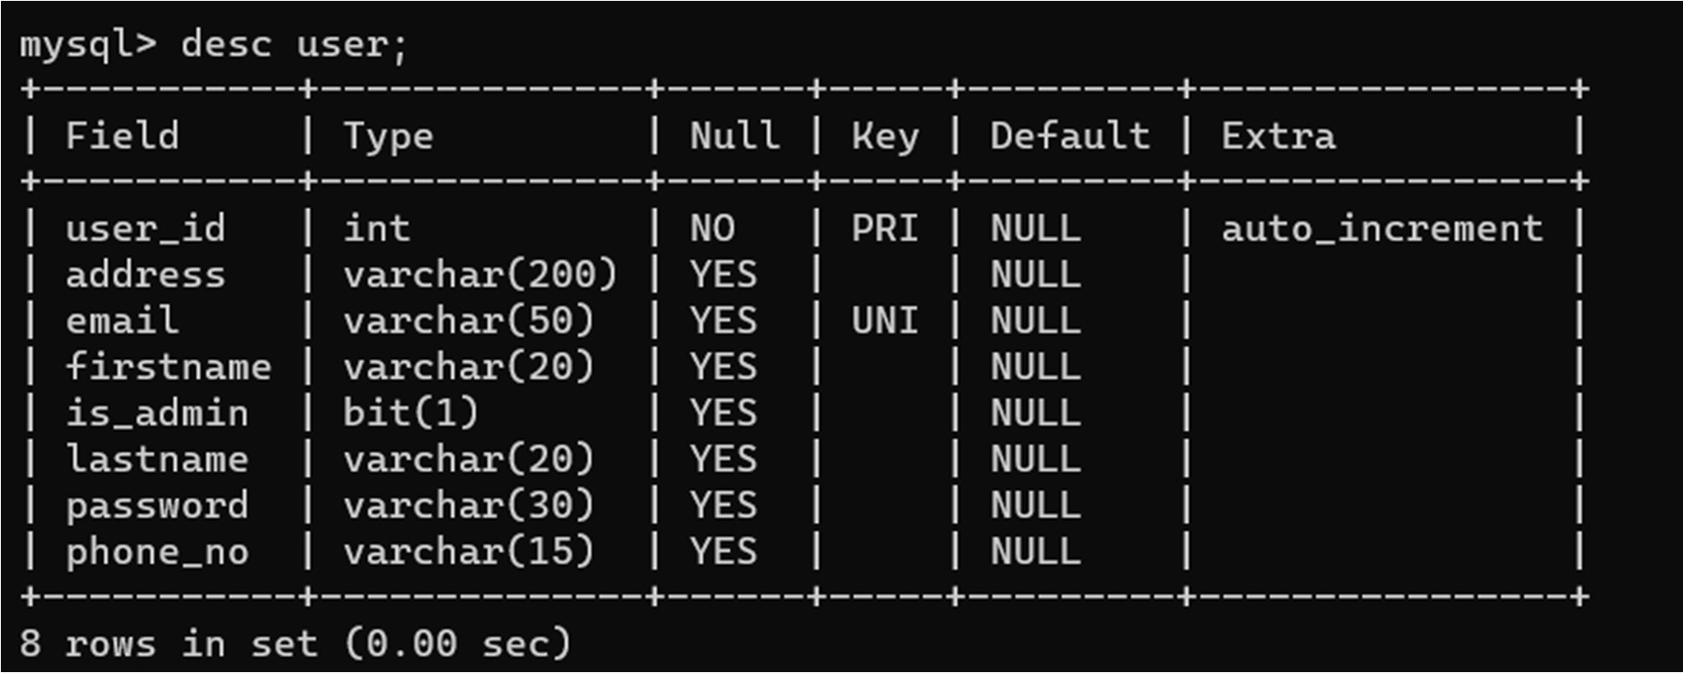

* 1. Farmers Table

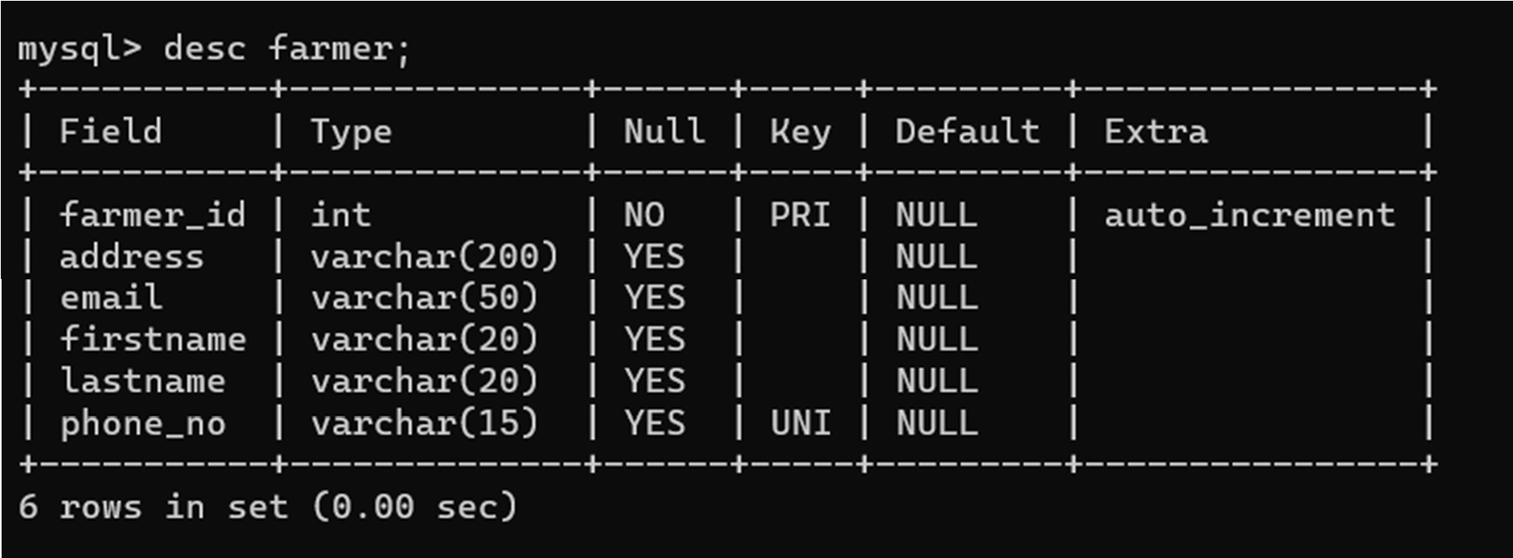

1. Tables Related to Orders
   1. Stock Details Table

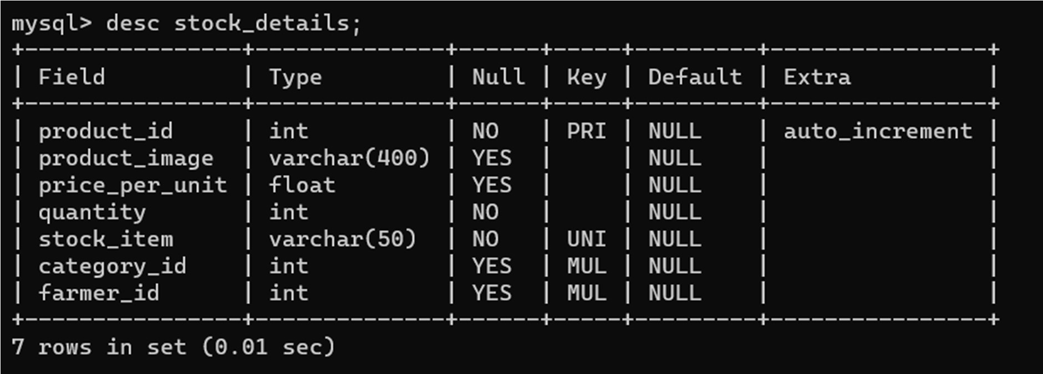

* 1. Orders Table

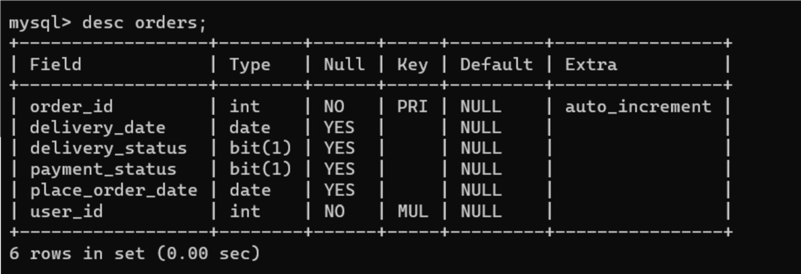

1. Order Details Table

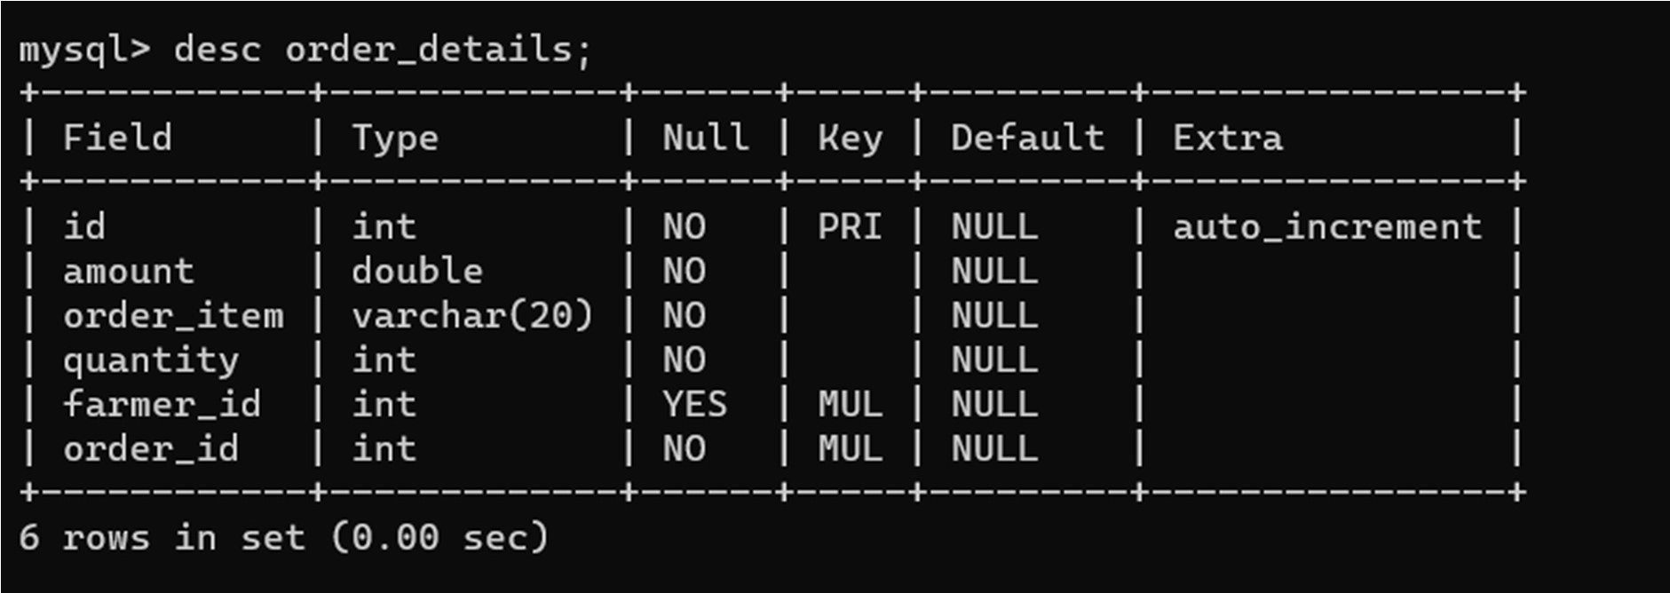

1. Category Table

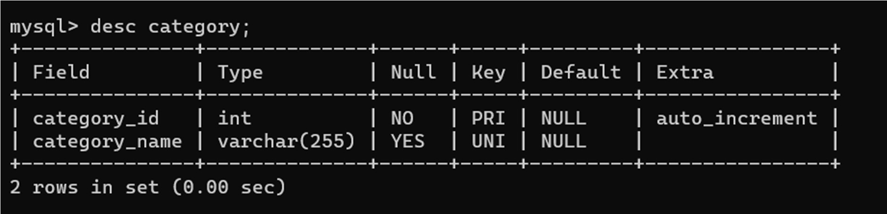

* 1. FUNCTIONAL DECOMPOSITION DIAGRAM

1. Admin Side DFD

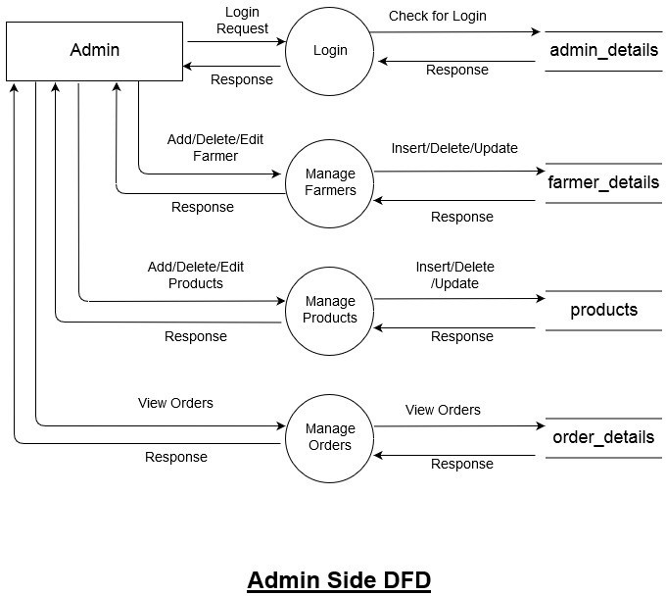



1. **User Side DFD**

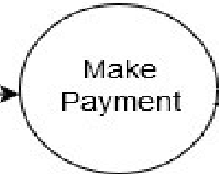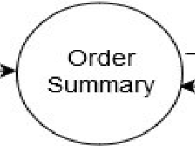

ln.s,ert Data

**User**

Registration Request

**1user_detaills**

Response

Login Request

G

Validate Data

**1user detaills**

Response

Response

Add

Request

Prod.uDI

Reque.st

**pmducts**

Re-sponse

**pmducts**

Search Request

Vlew Data

Ad.d/Edit Reque-st

Insert/ Edit Data

**,user detaills**

**order_details**

Response

Payment Detail,s

Insert Data

Response

**payment**

Response

View Details

Insert Data

**User Side DFD**

* 1. USE CASE DIAGRAM

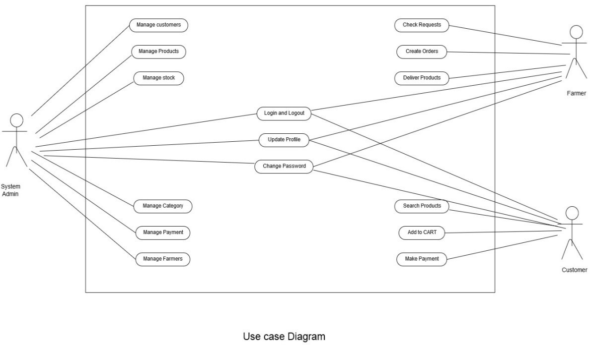

* 1. ACTIVITY DIAGRAM

1. **User**

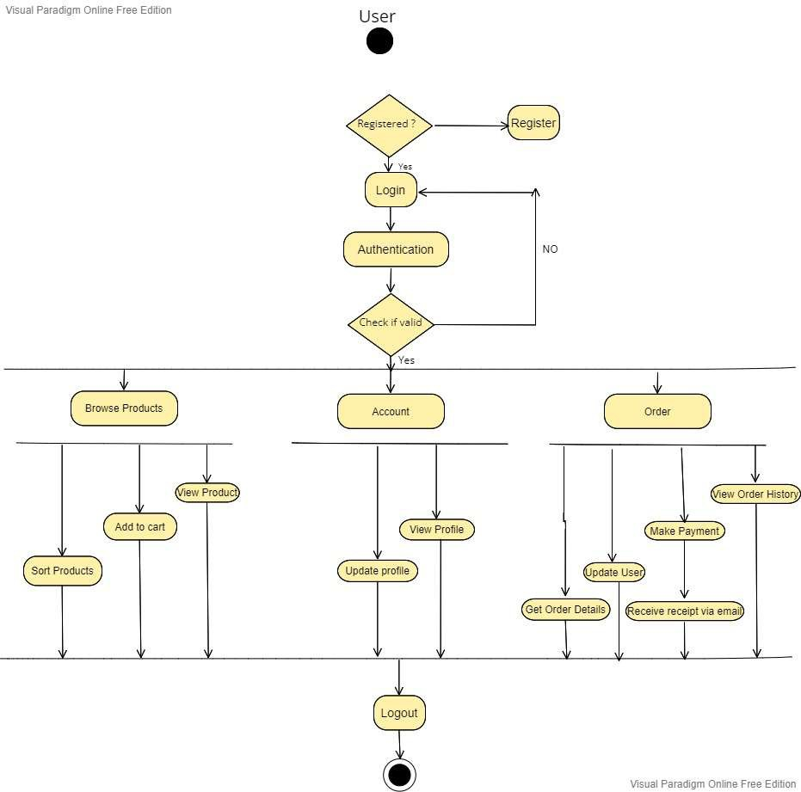

1. **Admin**

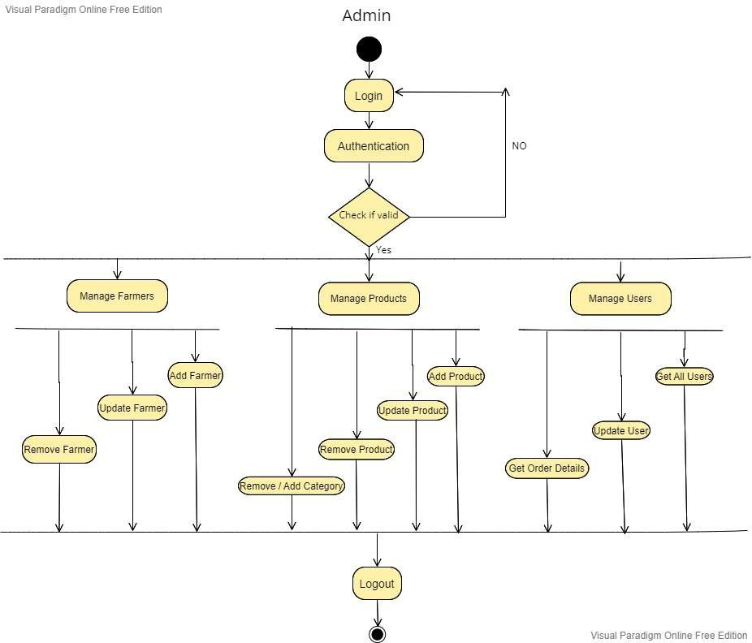

* 1. PROJECT ARCHITECTURE

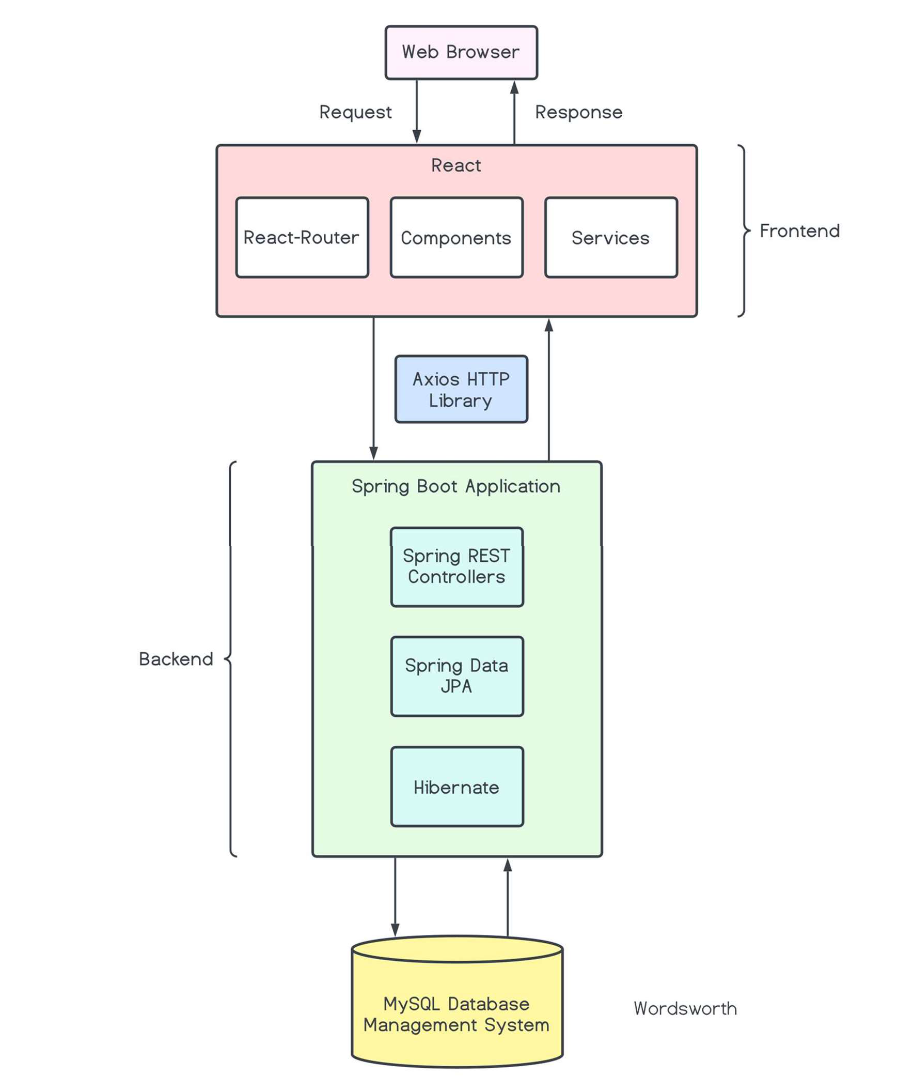

* 1. ER DIAGRAM

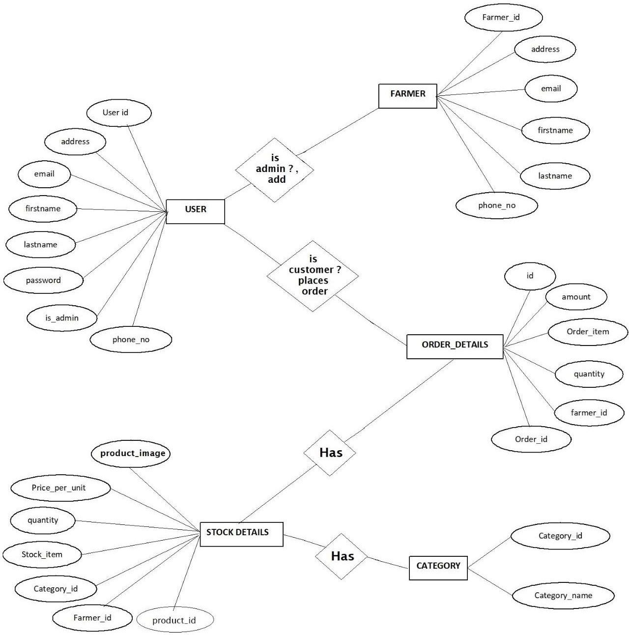

## PROJECT SCREENSHOTS

#### USER

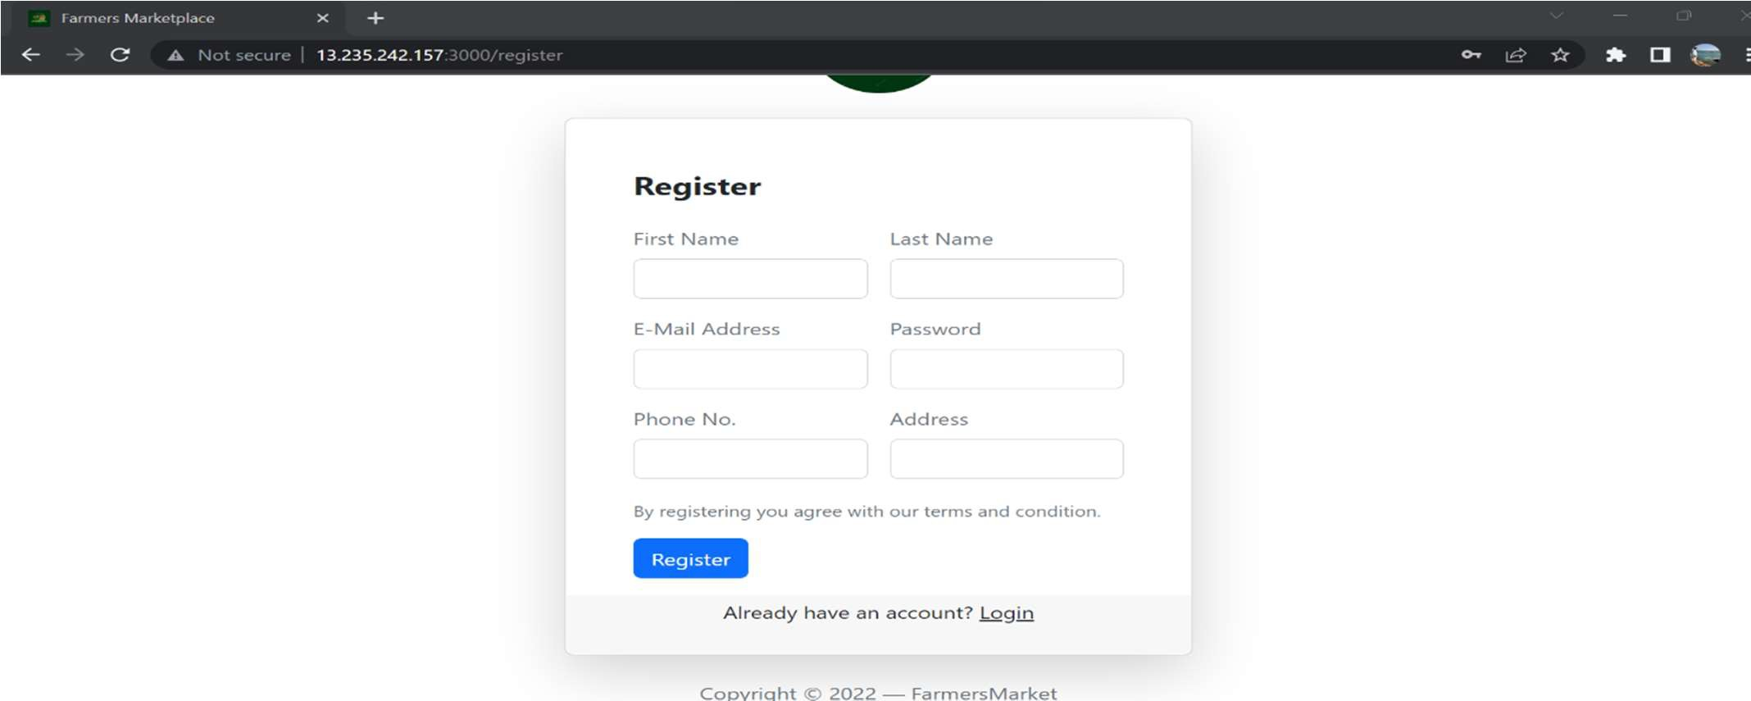

Register

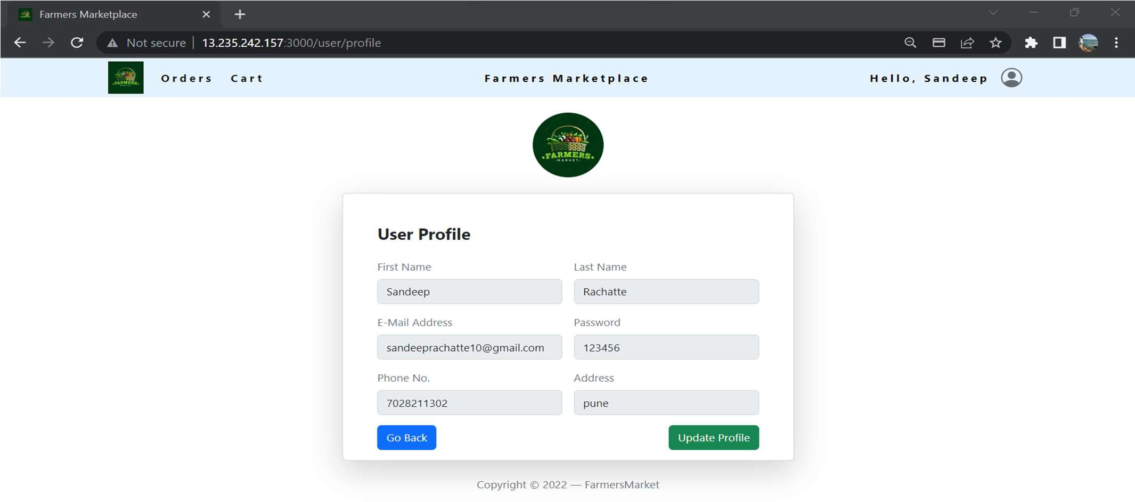

Login

Home Page

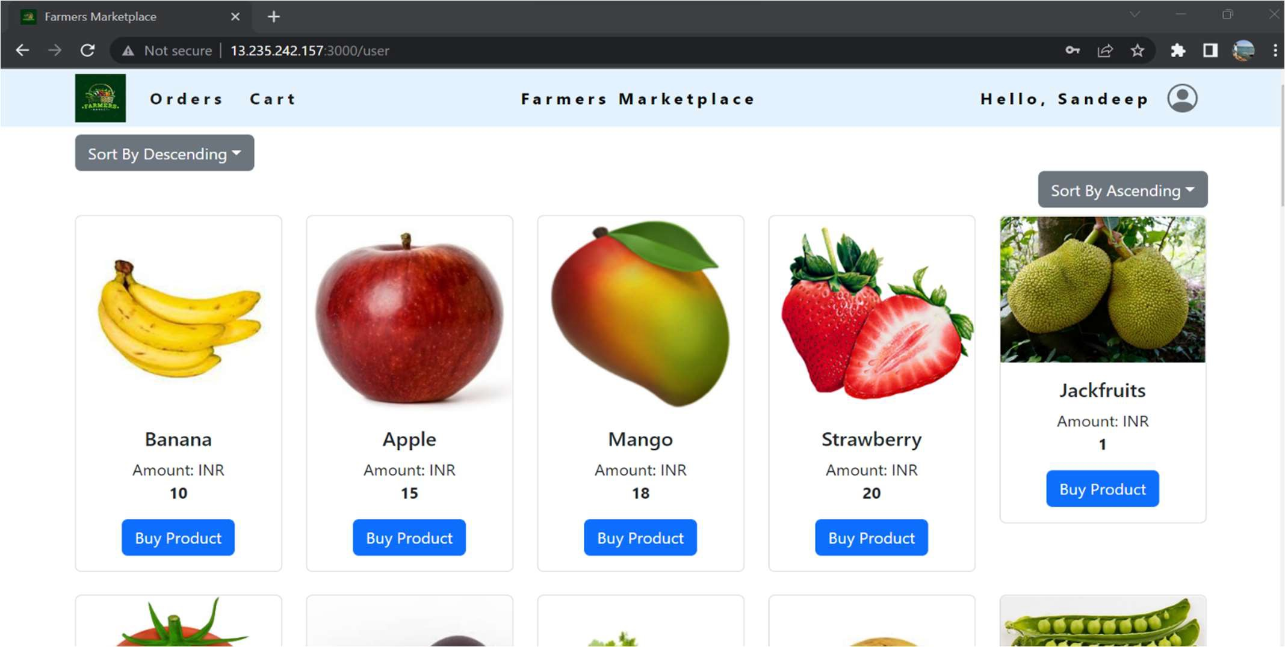

User Profile

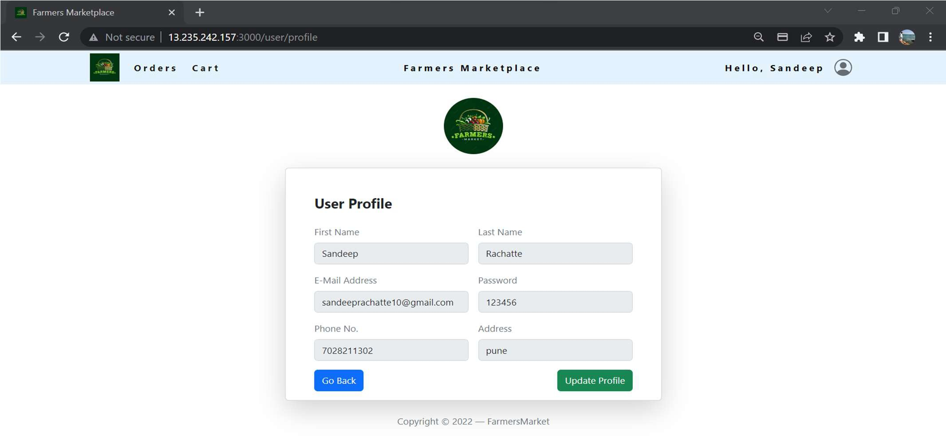

User Cart

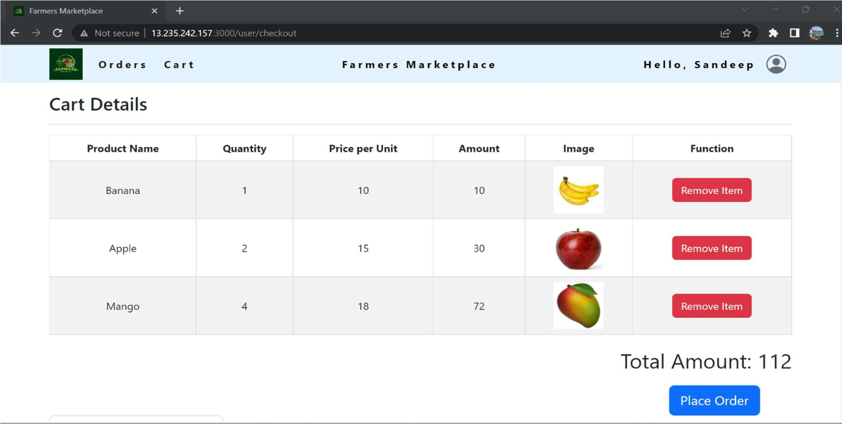

Order History

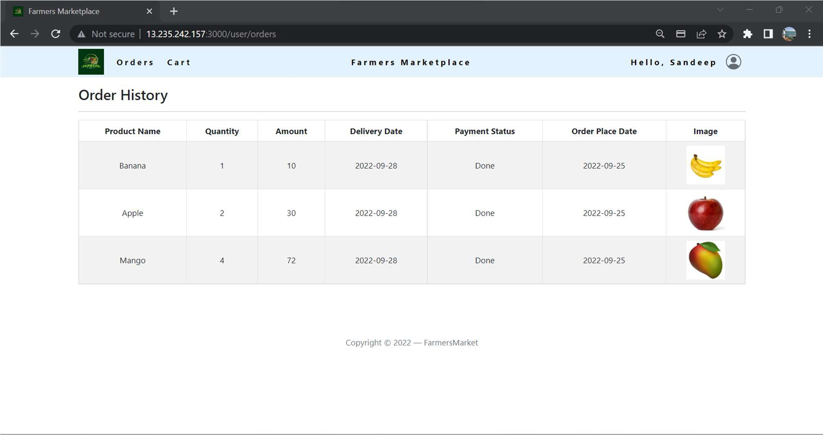

Empty Cart

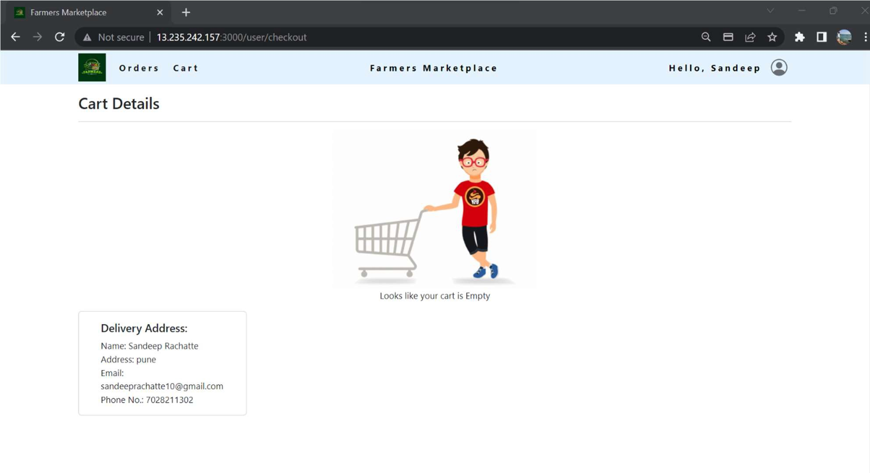

Sort Products

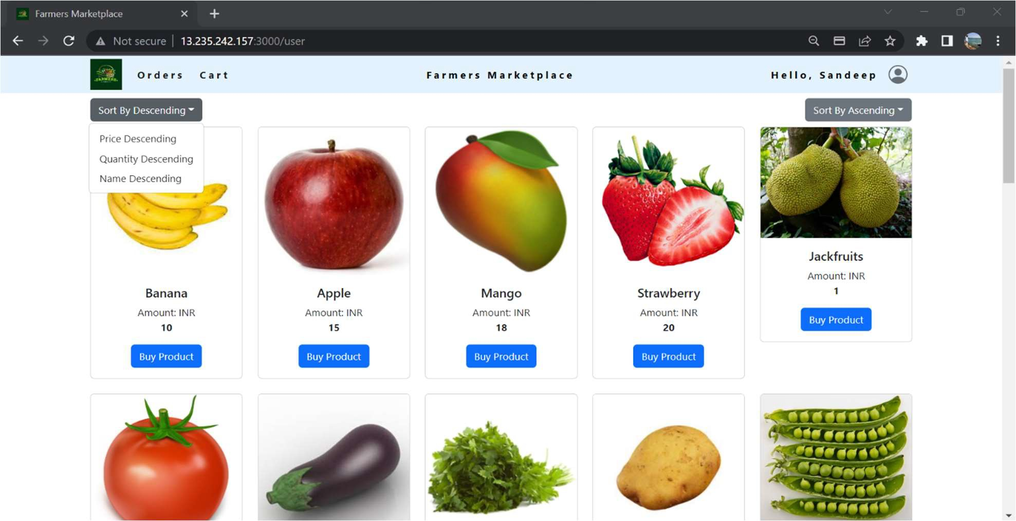

Payment Gateway

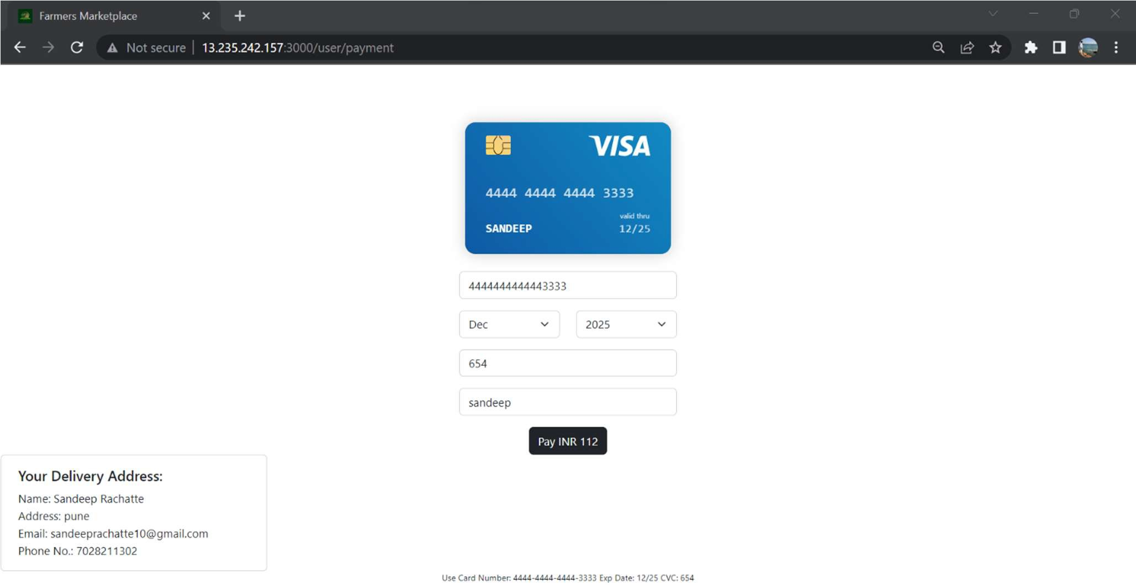

#### ADMIN

Admin Dashboard

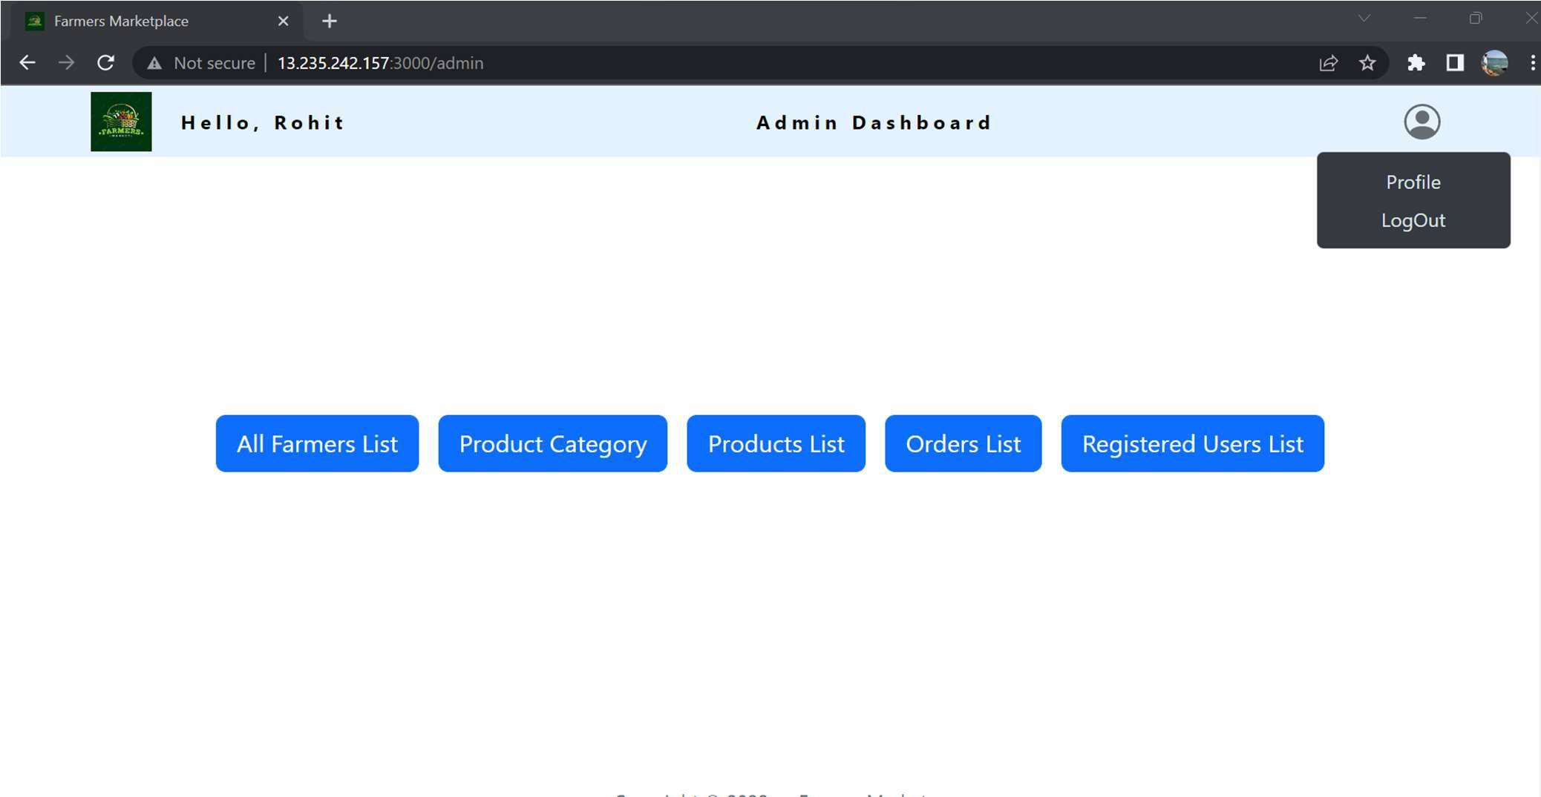

View All Users

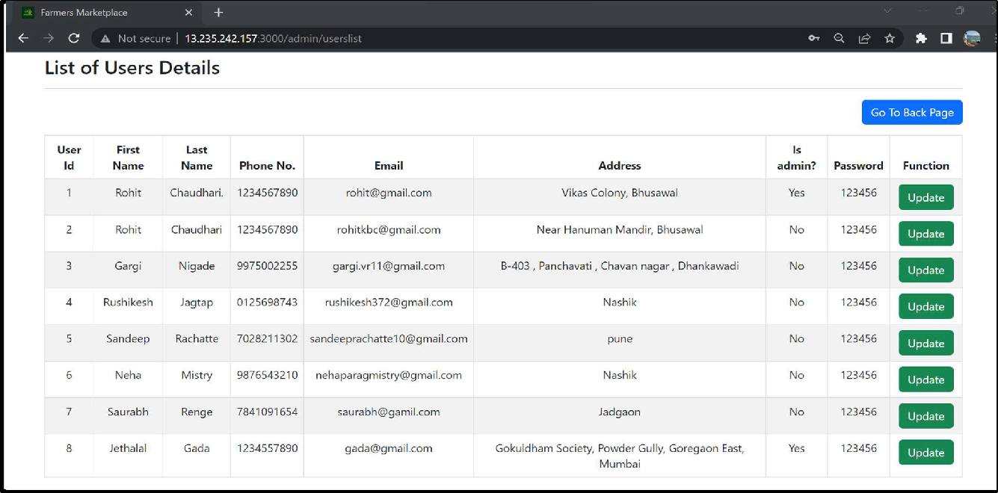

Add New Farmer

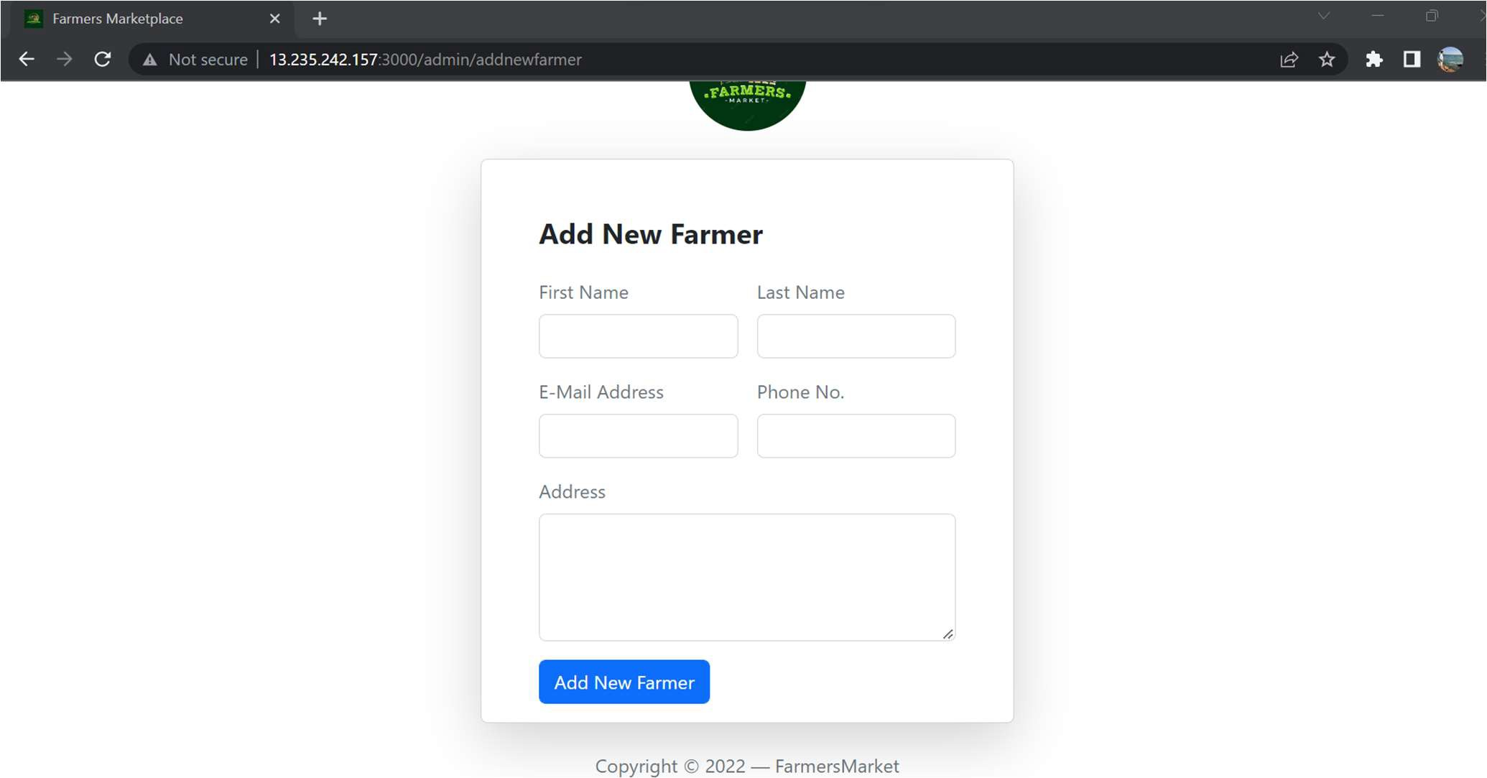

Admin Profile

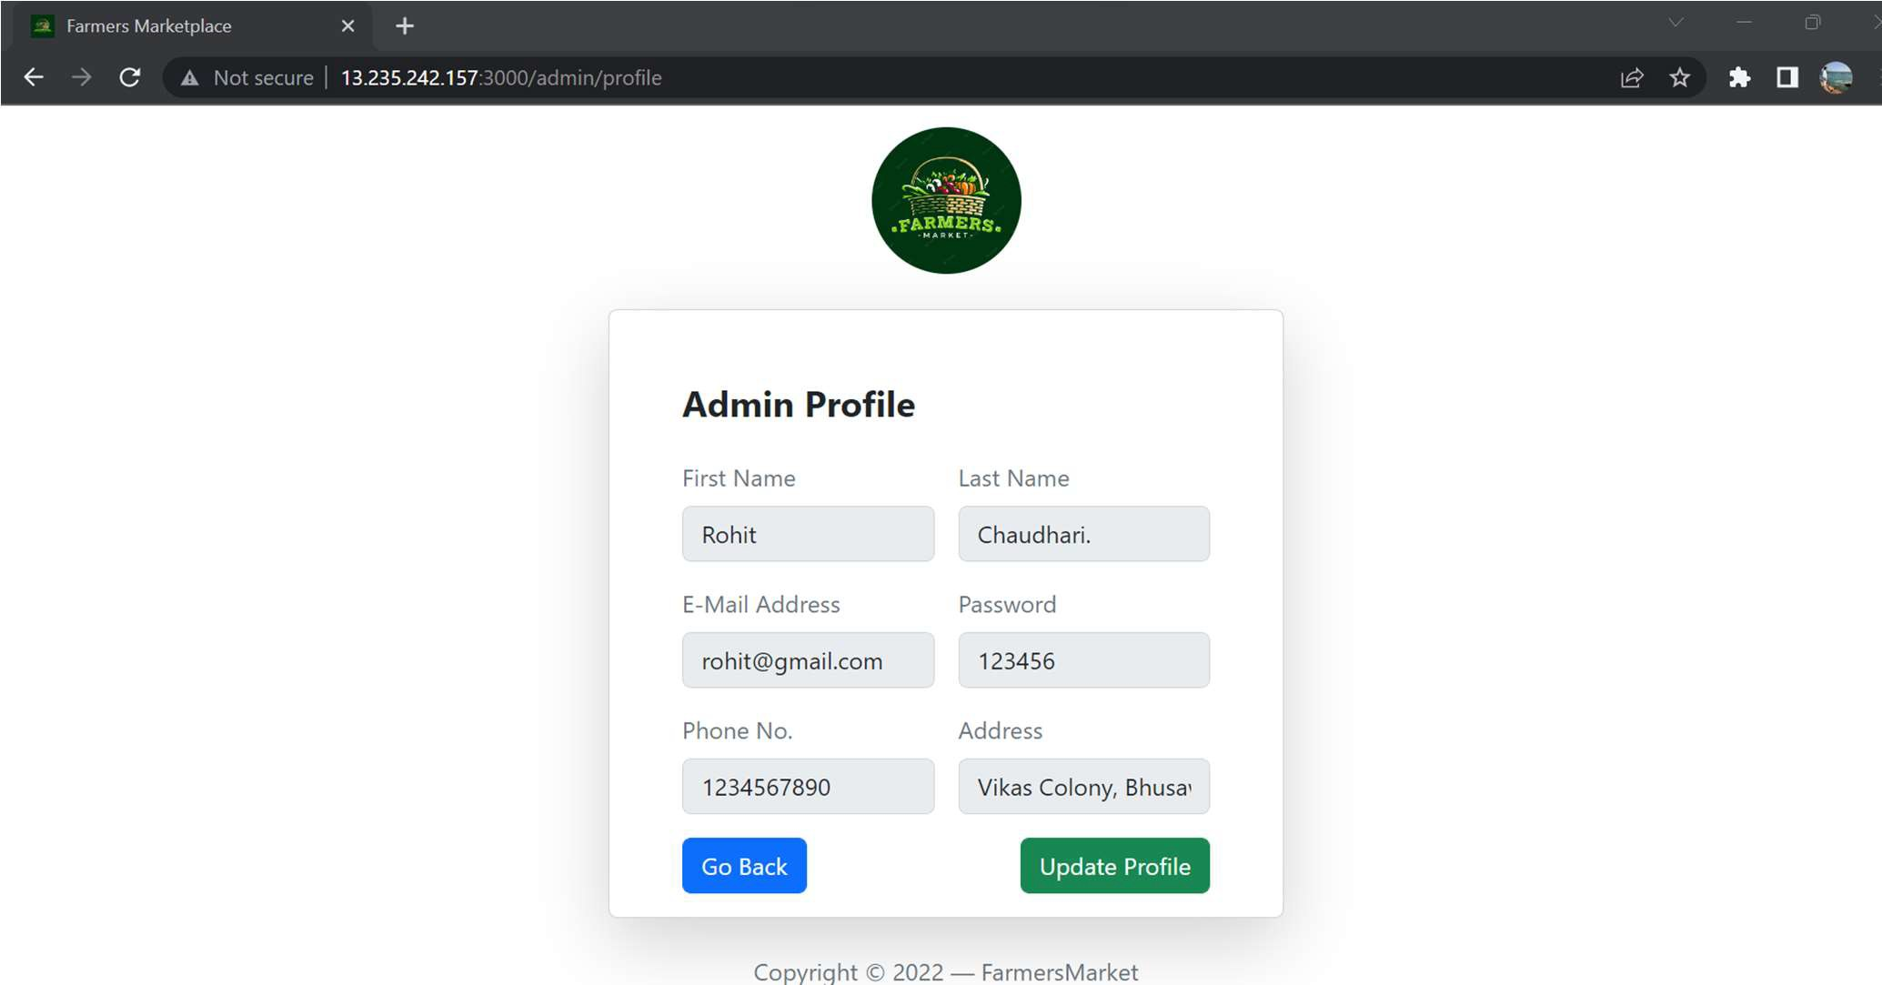

List of Farmers

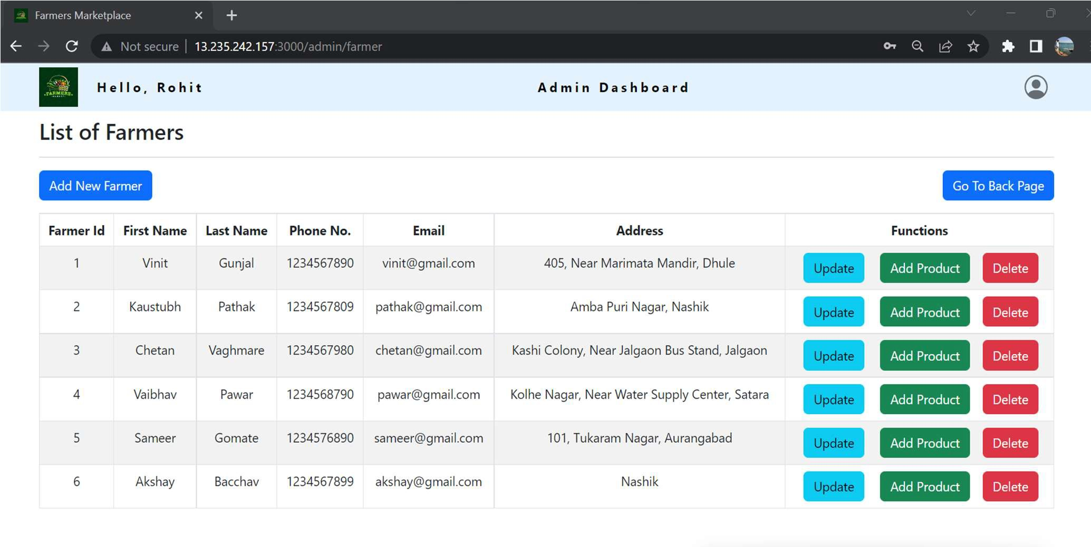

Update User Details

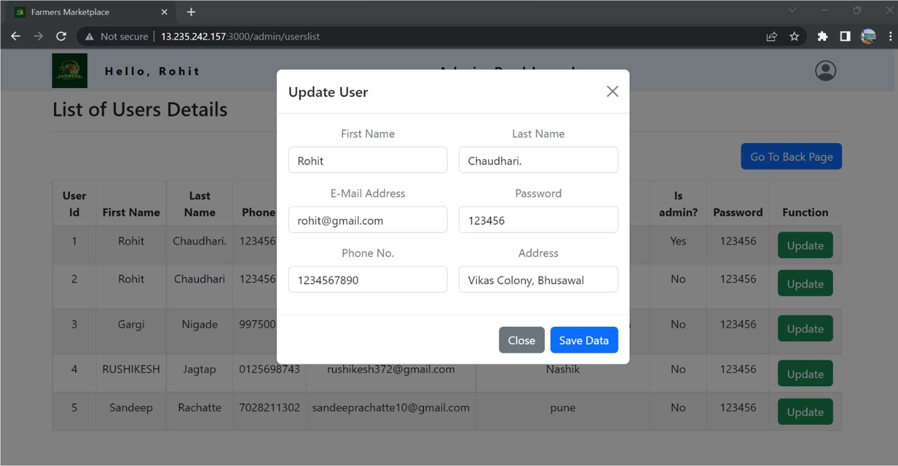

Add Category

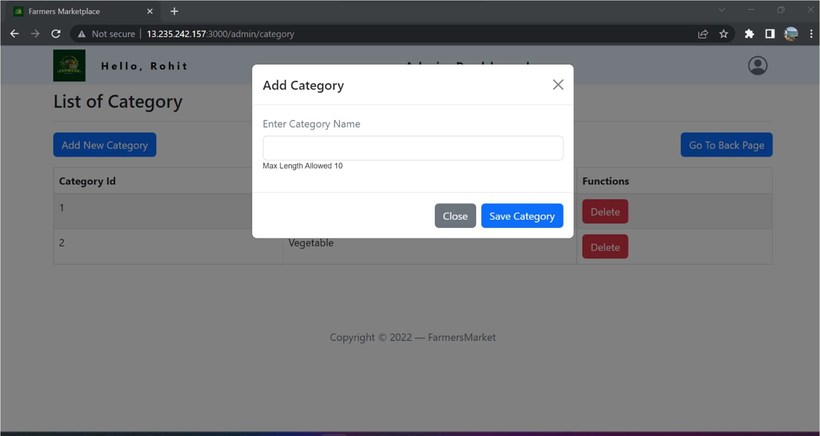

List of Category

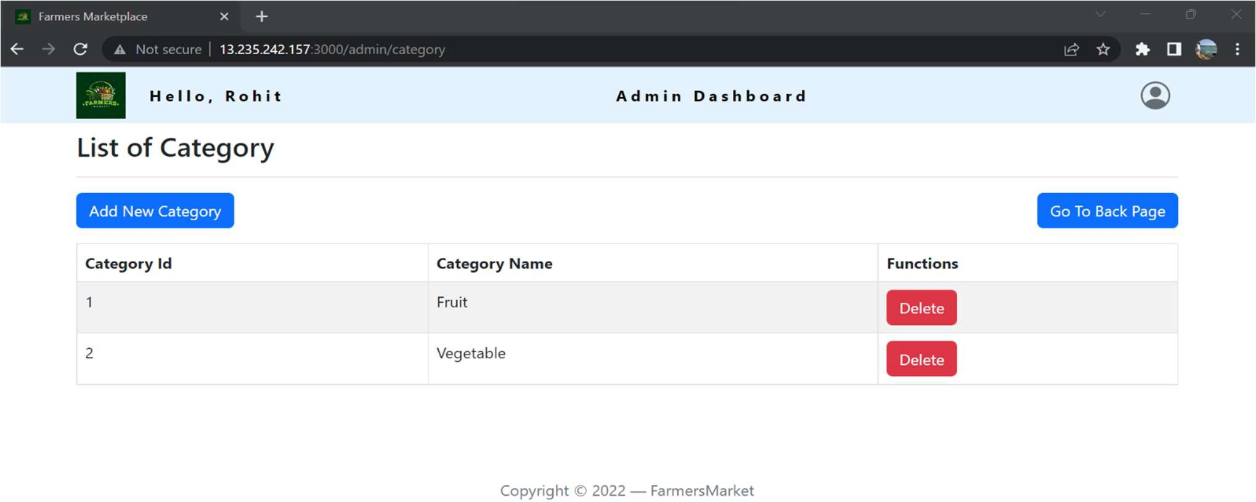

List of Products

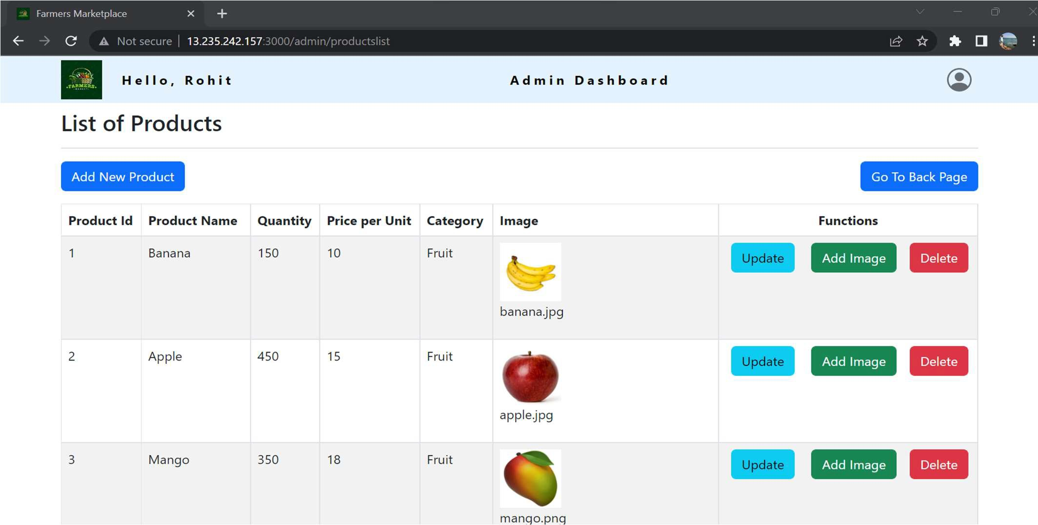

Add New Product

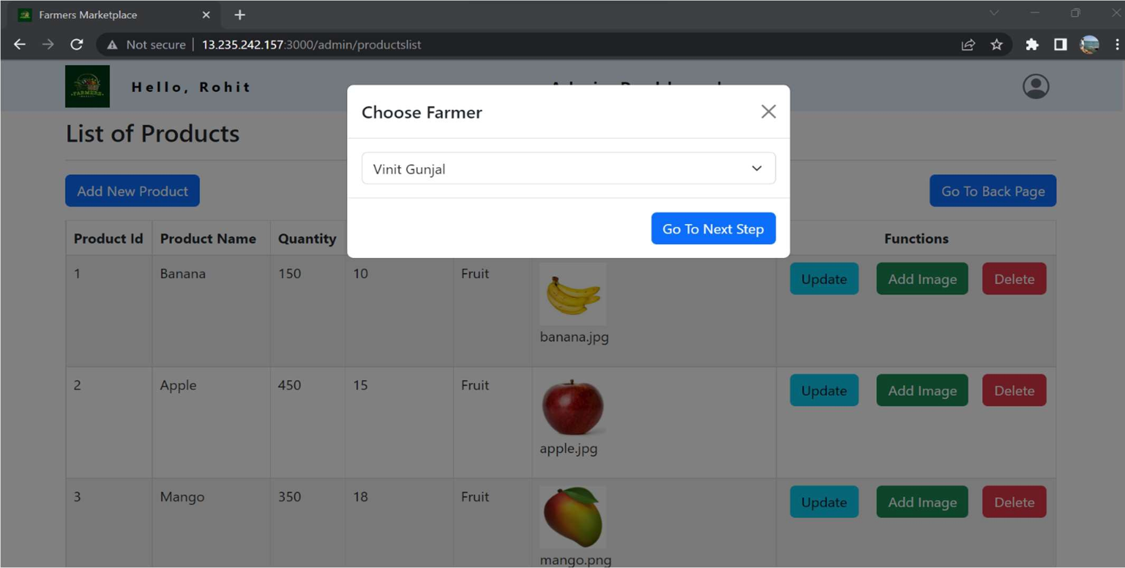

Order Details

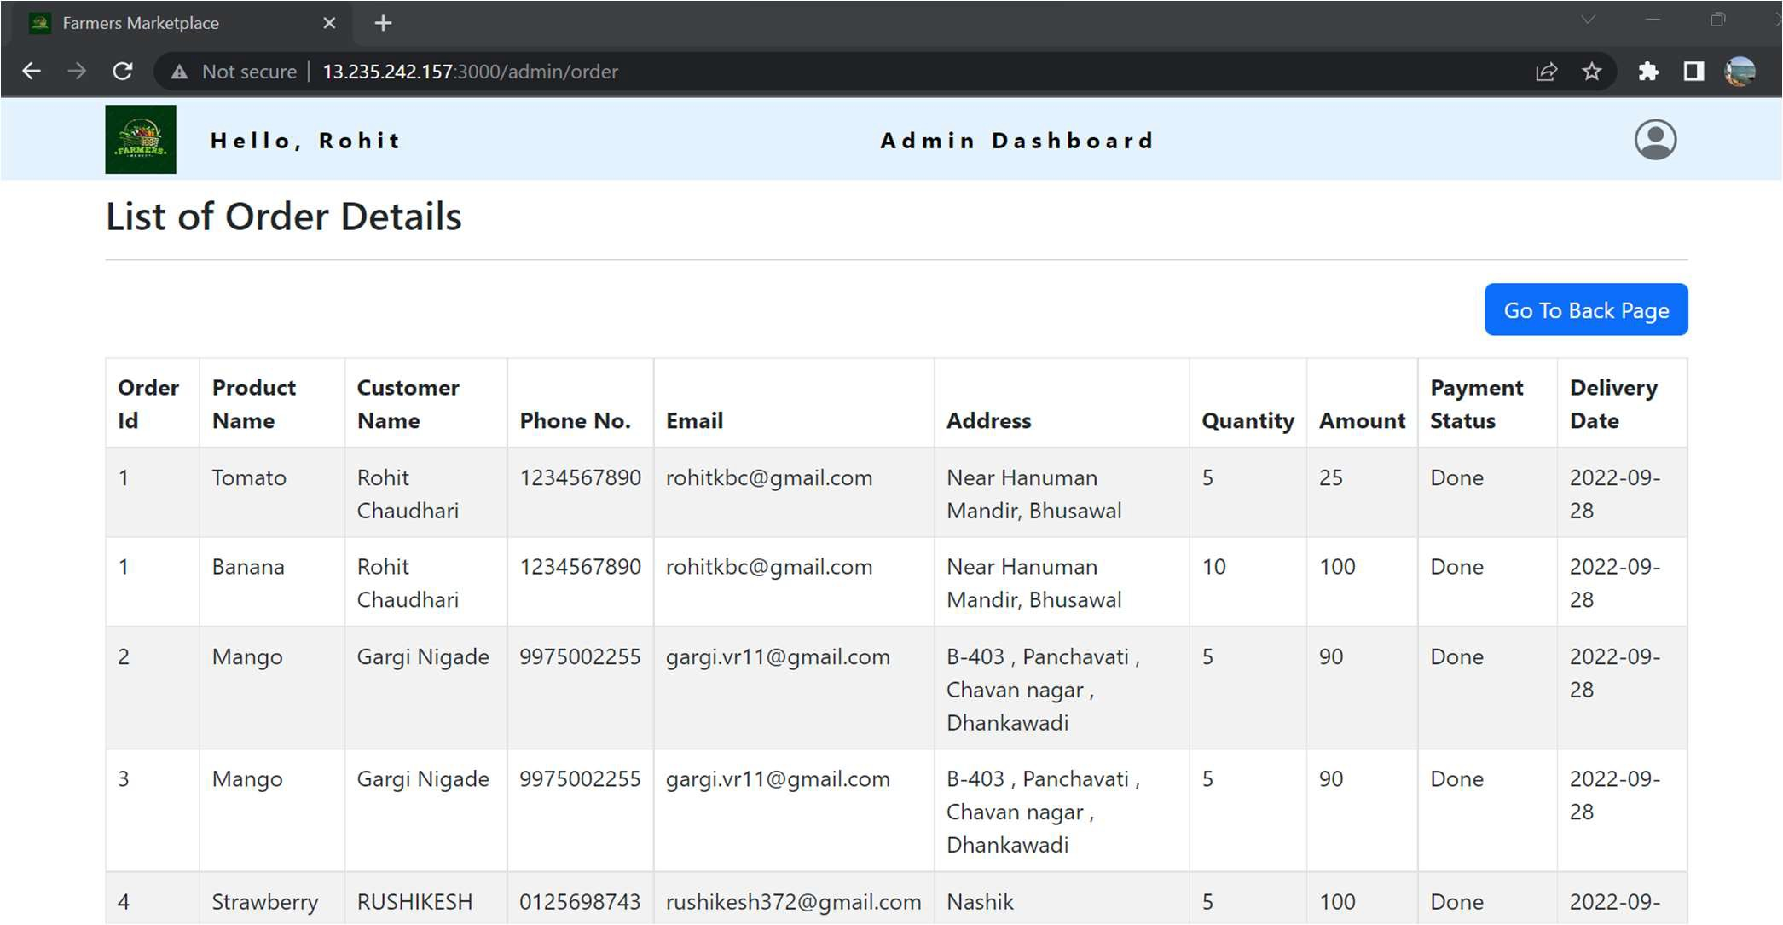

# TESTING

One of the main purposes of testing is to validate and verify that the system works as intended. No program or system design is perfect. However, if we implement the system without proper testing, then it may cause problems and lead to a bad user experience.

Testing and checking outcomes of each test gives us the best chance to detect and

correct errors before the system is implemented in a production environment.

In the course of our project, we made an effort to manually test each component. In

all cases, we obtained the desired results as demonstrated below.

1. CUSTOMER FEATURES TEST

|  |  |  |  |
| --- | --- | --- | --- |
| # | Description | Outcome | Result |
| 1  . | Register as Customer | New customer details saved in thedatabase. | Passed |
| 2  . | Login as Customer | Fetched authenticated user details saved in  database. | Passed |
| 3 | Browse Products | Fetched list of all products from the database. | Passed |
| 4 | Add Food items to Cart | The product along with necessary details were saved in database in the customer’s cart. | Passed |
| 5 | Place Order | The cart items associated with the customer were saved in the form of a placedorder in the database. | Passed |
| 6 | View Order History | The past orders made by the customer were  fetched from the database. | Passed |
| 7 | Update User Profile | The profile information updates/ modifications get reflected in Database | Passed |
| 8 | Logout | The session was cleared. | Passed |

1. ADMIN FEATURES TEST

|  |  |  |  |
| --- | --- | --- | --- |
| # | Description | Outcome | Result |
| 1. | Sign in as Admin | Fetched authenticated user details saved indatabase. | Passed |
| 2. | Add New Farmers | The Farmer details along with all theirrelated details were added to database. | Passed |
| 3. | Update/ Delete Farmers | The Farmer details along with all theirrelated details were updated to database. | Passed |
| 4. | Add New Product Category | New product-category gets added to database. | Passed |
| 5. | Add New Product Item | New item and all its respective details saved in database. | Passed |
| 4. | Manage Product stock | The stock of the product was updated in the database. | Passed |
| 5. | Update/Delete Product Details | The details of an existing product wereupdated/deleted in the database. | Passed |
| 6. | View Customer List | All Customers details are fetched from the database. | Passed |
| 7. | Update/Delete Customer Details | The details of an existing Customer updated/deleted in the database. | Passed |
| 8. | View order details | All Orders placed by all customer are fetched from the database. | Passed |
| 9. | Logout | The session was cleared. | Passed |

# CONCLUSION

“Cultivator’s Corner”, an online Grocery store application, was developed by our project team to simplify the online sale and purchase of Fresh-organic merchandise.

We tried using the latest technologies that are cross-platform and robust. Each and every software we used was open-source in nature, which keeps the cost of production at a minimum.

We were also meticulous about the user experience aspect of our application so that navigating our website is an easy and seamless experience.

In conclusion, “Cultivator’s Corner” is an application would definitely be a good choice for any fresh-food merchandise trading Farmers that wishes to enter the online market. At the same time, it provides one-stop platform for Customers to purchase their daily need of merchandise directly from authenticated Farmers.

We are confident that the numerous features and visually appealing look of application will certainly give a big boost to the Farmers.

## FUTURE SCOPE

Using whatever we have learnt over the duration of this course, we tried to make our project as user-friendly and gave it as many features as possible in the limited time allotted for the project work. That said, there are certainly more features that can be added to our application. Some of those are mentioned below:

1. The most purchased and/or sponsored products can be highlighted as customer favorites to promote merchandise further.
2. Rating chart for Farmers and Products.
3. Product Display based on Categories, distributing Farmers and respective ratings.
4. Discounts can be given on a per-user basis depending on the customer’s

purchase history as well as how many products they buy at the same time.

1. Customers can upvote/downvote/report feedbacks.
2. Additional payment means can be added other than cards.
3. In case the user forgets the password, a ‘reset password’ functionality can be added.
4. CAPTCHA can be added to login page.

# REFERENCES

Following is the list of websites we referred during the course of our project:

1. https://getbootstrap.com/docs/5.1/getting-started/introduction/
2. https://reactjs.org/docs/getting-started.html
3. https://[www.baeldung.com/](http://www.baeldung.com/)
4. https://[www.w3schools.com/](http://www.w3schools.com/)
5. https://docs.spring.io/spring- data/jpa/docs/current/reference/html/#reference
6. https://javaee.github.io/javaee-spec/javadocs/
7. https://javadoc.io/doc/org.springframework.data/spring-data- jpa/latest/index.html
8. https://github.com/amaroteam/react-credit-cards